Berkshire Maestros Pupil Premium Financial Support Request Form
As of September 2020, Berkshire Maestros currently are able to provide a 75% reduction on group lessons or a 40% reduction on individual 20 minute lessons for Pupil Premium students. If you would like to apply for this, Maiden Erlegh School in Reading will need to confirm your eligibility, so please complete this form so we know what lessons you have applied for.
The school may be able to pay the remainder of the 25% for group lessons or the equivalent monetary support for Berkshire Maestros lessons.
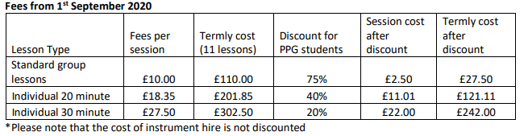.

Student Name |  |  |  | School
Tutor Group |  |  |  | Date
Instrument applied for
Type of lesson (please circle) | Standard group Individual 20 minute Individual 30 minute
If you would like to apply to receive the remainder of the 25% for group lessons or the equivalent monetary support from the school, please tick here [ ]

Please return this form to Mr Butchers
OFFICE USE ONLY

The above expenses and contribution have been approved by:
Signed (SAHT) |  |  | Date:
Agreed to top up | Yes No |  | Signed:

